**273/2**

**GEOGRAPHY**

**PAPER 2**

**2 ½ Hours**



**ERETA EDUCATION CONSULTS**

**JOINT MOCK EXAMINATIONS 2022**

**UGANDA CERTIFICATE OF EDUCATION**

**GEOGRAPHY**

**PAPER 2**

**2 Hours 30 minutes**

**INSTRUCTIONS**

Answer **four** questions in all.

Choose **two** questions from part **I** and **two** from part **II**.

In part **II**, only **one** question should be chosen from any **one** region.

Additional question(s) answered will not be marked.

# PART I: THE REST OF AFRICA

*Answer* ***two*** *questions in this part.*

1. (a) Draw a sketch map of Africa and on it mark and name:

1. vegetation types: Mediterranean, Montane and dry Savanna (sahel) vegetation,
2. Latitudes: Tropical Cancer and Tropical of Capricorn
3. South Westerly winds,
4. Guinea Ocean current. (8 marks)
5. (i) Describe (i) the characteristics of any One of the types of vegetation named in

a(i) above. (4 marks)

(ii) the conditions which have favoured the growth of the vegetation type chosen in

b((i) above. (4 marks)

1. Explain the effects of human activities on natural vegetation in Africa. (6 marks)
2. State any two countries occupied by the vegetation type identified in (b)

(i) above. (2 marks)

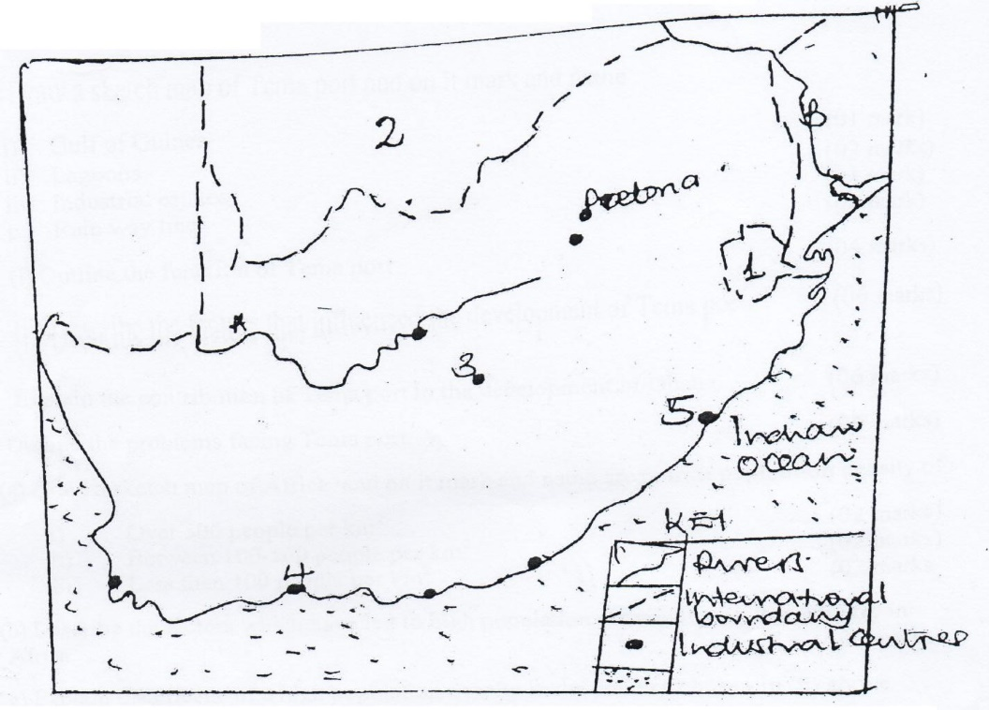2. Study figure 1 below of the Republic of South Africa and answer the questions that follow.

(a) Name the;

1. Rivers A, B (2marks)
2. Countries 1, 2 (2marks)
3. Industrial centres 3, 4, 5 (3marks)

(b). (i) State any two industries found in any one industrial town named in (a) (iii) above.

(2marks)

(ii) Giving specific examples, describe the factors that have favoured the development of industries in the Republic of South Africa. (6mark)

1. Explain the contribution of the industrial sector to the development of the republic of

South Africa. (6marks)

1. Outline the steps being taken to improve the industrial sector in the Republic of South Africa. (4marks)
2. a) Draw a sketch map of Africa and on it mark and name areas with population density of:

i) Over 500 people per Km2 (02marks)

ii) Between 100 – 500 people per km2  (02marks)

iii) Less that 100 people per km2 (02marks)

* + 1. Giving specific examples, describe the factors which have led to high population density in any one country in Africa. (06marks)
    2. Explain the effects of a high population density in the country chosen in (b) above. (08marks)
    3. Outline the steps being taken to address the challenges of a high population

density in the country chosen above. (03marks)

1. Study the table below showing rubber export form Liberia 1998-2003 and answer the questions that follow.

|  |  |
| --- | --- |
| **Year** | **Rubber exports in ‘000 metric tonnes** |
| 1998    1999    2000    2001    2002    2003 | 1230    1140    1479    1540    1170    1000 |

***Adapted 2005 Africa Development indicator. The World Bank, Washington DC pg 99***

a) Draw a line graph to represent the trend in rubber exports form Liberia between

1998-2003. (07marks)

b) Describe the trend in rubber export shown in (a) above. (04marks)

c) Giving specific examples describe the physical conditions that have favoured

|  |  |
| --- | --- |
| rubber growing in Liberia. | (08marks) |
|  |  |
| d) Outline the benefits of rubber growing to the people of Liberia. | (06marks) |

# PART II STUDIES IN DEVELOPMENT

*Answer* ***two*** *questions from this part*

## REGION I: NORTH AMERICA

5. Study figure 2, map of California provided and answer the questions that follow;

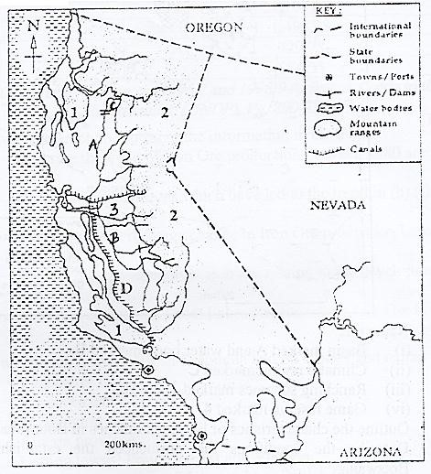

(a) Name the;

1. Rivers marked **A** and **B**
2. Dam marked **C**
3. Canal marked **D**
4. Mountain ranges marked **1** and **2**
5. Valley marked **3** (07marks)
6. (b) Giving specific example describe the conditions which have favoured irrigation farming in California. (08 marks)

(e) (i) Name any **one** type of fruit and **one** fibre crop grown in the irrigated of California.

(02 marks)

(ii) Explain the contribution of agriculture to the development of California. (06 marks)

(d) Outline the steps being taken to promote the agricultural sector in California. (02marks)

6. Study table II below showing Annual iron ore production for USA-Great Lakes Region between 1980 and 2000 and answer the questions that follow;

|  |  |
| --- | --- |
| **Year** | **Annual Iron Ore production (‘000) metric tonnes** |
| 1980 | 1,181.84 |
| 1985 | 1,105.43 |
| 1990 | 1,498.38 |
| 1995 | 729.78 |
| 2000 | 684.35 |

***Adapted: 2007 World Resources (1 996/7 and 1998/9 series). A Guide to the Global Environment (UNDP), Pg 290-338.***

(a) Draw a bar graph to represent the information in the table. (07marks)

(b) Describe the conditions which have led to the trend in

(b) (i) above. (08 marks)

(c) (i) Calculate the percentage change in Iron Ore production between 1980 and 2000.

(02 marks)

(ii) Explain the contribution of iron ore mining to the development of the Great Lakes

region. (06 marks)

(d) Name two areas around the Great Lakes Region where Iron Ore is mined. (02 marks)

7. (a) Draw a sketch map of British Columbia and on it mark and name:

1. Vancouver Island .
2. Alaska Ocean current
3. Washington state
4. Alberta province
5. Fishing towns: Prince Rupert and Victoria. (07marks)
6. (i) Name any two types of fish caught in British Columbia. (02 marks)

(ii) Giving specific examples, explain the factors which have favoured the

development of fishing in British Columbia. (08marks)

1. Describe any one method used in catching fish in British Columbia. (05 marks)
2. Outline the problems faced by the fishing industry in British Columbia. (03 marks)

**REGION II: THE RHINELANDS**

1. (a) Draw a sketch map of Switzerland and on it mark and name;
   * 1. Physical Regions: The Swiss Alps, Swiss plateau and Swiss Jura
     2. Rivers: Rhine and Rhone
     3. Tourism centres: St. Moritz, Interlaken and Geneva (10marks)
   1. (i) Giving specific examples, describe the factors that have favoured the

development of the tourism industry in the Swiss Alps (06marks)

* 1. Explain the contribution of the tourism industry to the development of Switzerland (06 marks)
  2. Name three tourist attractions found in both East Africa and Switizerland.

(03Marks)

1. Study table **IV** showing the volume of cargo handled by the Rhine water way (2006-2011) and answer the questions which follow.

Table IV volume of cargo handled by the Rhine waterway (2006-2011)

|  |  |
| --- | --- |
| **Year** | **Volume of cargo (in ‘000 metric tonnes)** |
| 2006  2007  2008  2009  2010  2011 | 82,200  84,500  87,050  90,000  95,100  96,250 |

(a) Draw a line graph to show volume of cargo handled by the Rhine waterway between

2006 and 2011 as reflected in the table. (08 marks)

(b) Describe the:

1. trend of the volume of cargo handled by the Rhine water way between 2006 and

2011. (02 marks)

1. factors which have contributed to the development of the Rhine river as an

important water way. (06 marks)

1. Explain the benefits of the Rhine water way to the Rhine lands. (06 marks)
2. Outline the problems faced by the Rhine waterway. (03 marks)

10.a) Study figure 2 Map of Netherland showing Dai fag areas and answer the questions

that follow:

## Figure 2 : Map of Netherlands

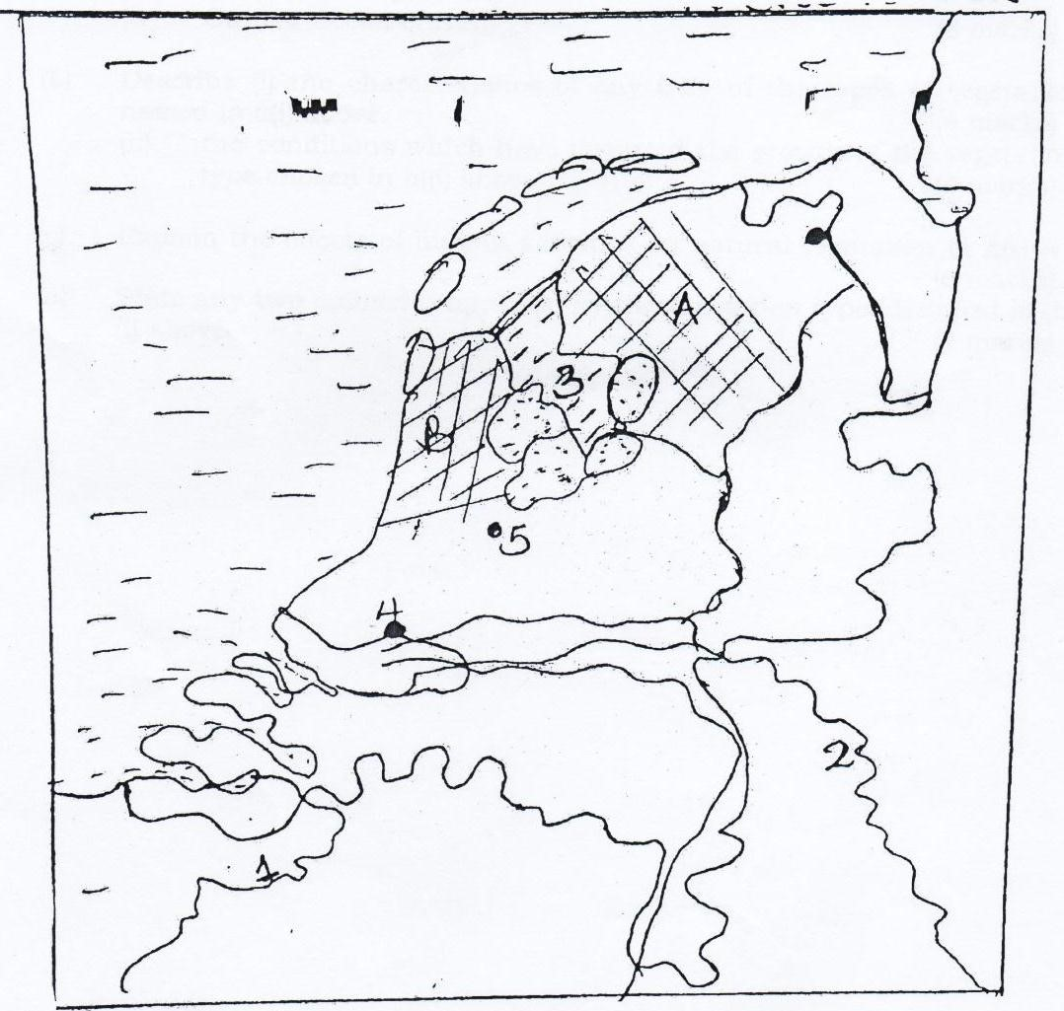

1. Name:
   1. Rivers: 1 and 2 (02marks)
   2. Water bodies: 3 (01mark)
   3. Dairy farming areas: A and B. (02mark)
2. (i) Name any two cattle breeds reared in Netherlands, (02marks)

(ii) Giving specific examples, describe the factors which have favoured dairy farming in

Netherlands. (06marks)

(e) Explain the benefits of dairy farming in Netherlands. (06tnarks)

(d) Outline the problems being faced by the dairy sector in Netherlands. (04marks)

***END***